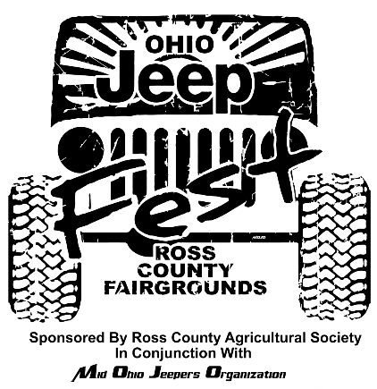
4th Annual Ohio Jeep Fest Sponsorship packages
July 3, 4, & 5, 2020
Contact Barry Haubeil at (740)703-5778 or barryhaubeil@yahoo.com
P.O.Box 614 Chillicothe OH 45601

This year give your company the chance to be a title sponsor of one of the courses offered at the Ohio Jeep Fest. We are offering your company the chance to sponsor one of our obstacle courses, mud pits, and/or trail. These 4 packages will only be available to 1 company for each course so please contact us prior to sending in your sponsorship.

TITLE SPONSOR
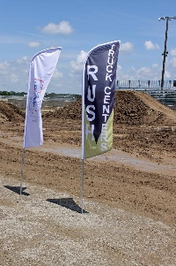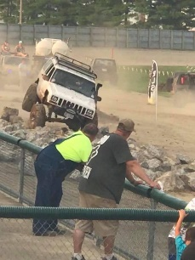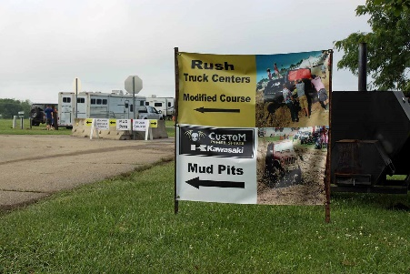
We are offering you the chance to be the exclusive sponsor of our Modified obstacle course. This obstacle course has something for every Jeep enthusiast including rocks, pole bridge, and even a teeter totter. We also hold our Trail Rated Challenge on this course. With this package you will be able to promote your product at our modified obstacle course with signs, flags, gear, Jeeps, and swag of your choosing.
For a donation of $10,000.00
- Exclusive sponsorship of the modified obstacle course.
- Your company name located under the official Ohio Jeep Fest logo along with Ross County Agricultural Society, Mid Ohio Jeepers Organization, and Herrnstein Automotive Group.
- Individual company signage at the event.
- Link to your business website on http://ohiojeepfest.com/
- Your company logo on the website http://ohiojeepfest.com/
- Live announcements by ChillicotheDJ throughout the entire event.
- Company logo on a loop on the electronic sign at the entrance of the Ohio Jeep Fest.
- Vendor Spot.
- All access pass for both obstacle courses and mud pits.
- 50 Weekend passes for the Ohio Jeep Fest.
- 20 official Ohio Jeep Fest t-shirts.
- 2 campsites with water and electric for the weekend of the event.
- Title sponsor of the Trail Rated Challenge.

STOCK COURSE SPONSOR
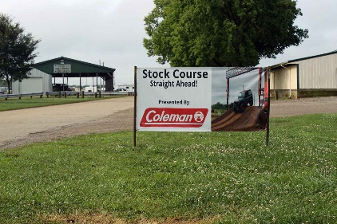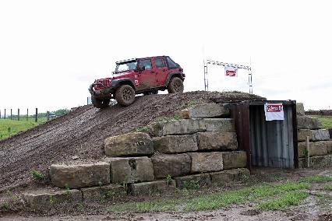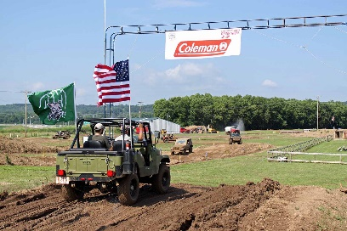
Our stock course that is provided by Chillitown MX is up for grabs this year. Now your company has the chance to sponsor our most popular obstacle course at the Ohio Jeep Fest. This course has every Jeep enthusiast smiling when they are on it. This is a great course for beginners with a stock Jeep or more experienced Jeepers that just want to get the family out and give them a safe and fun experience. This track is over 1 mile long and gets everyone’s attention when they are at the Ohio Jeep Fest.
For a donation of $5,000.00
- Exclusive sponsorship of the stock obstacle course.
- Individual company signage at the event.
- Company name on the back of the official Ohio Jeep Fest t-shirts.
- Link to your business website on http://ohiojeepfest.com
- Company logo on the website http://ohiojeepfest.com
- Live announcements by ChillicotheDJ throughout the entire event.
- Company logo on a loop on the electronic sign at the entrance of the Ohio Jeep Fest.
- Vendor Spot.
- All access pass for both obstacle courses and mud pits.
- 20 Weekend passes for the Ohio Jeep Fest.
- 15 official Ohio Jeep Fest t-shirts
- 2 campsites with water and electric for the weekend of the event.

MUD PIT SPONSOR
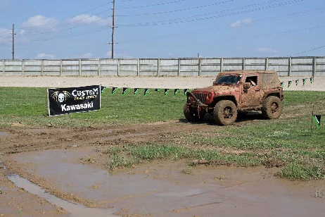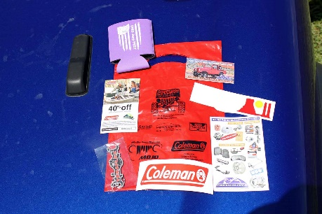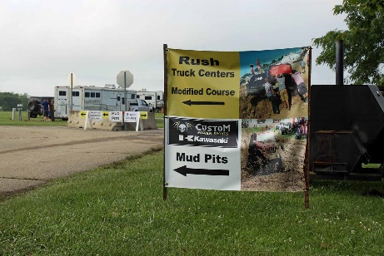
Our mud pits have a constant line of people just waiting to challenge their Jeeps. We have 2 sides to our mud pits and “mild” mud pit and an “modified” mud pit. We are giving you the opportunity to be the exclusive sponsor of our mud pits. Jeeps line up along the mud pits as well as people filling the bleachers to watch. This will be a focal point of our Jeep Fest and an awesome opportunity to advertise for your company.
For a donation of $2,500.00
- Exclusive sponsorship of the mild and modified mud pits.
- Individual company signage at the event.
- Company name on the back of the official Ohio Jeep Fest t-shirts.
- Link to your business website on http://ohiojeepfest.com
- Company Logo on the website http://ohiojeepfest.com
- Live announcement by ChillicotheDJ throughout the entire event.
- Company Logo on a lop on the electronic sign at the entrance of the Ohio Jeep Fest.
- Vendor Spot
- All access pass for both obstacle courses and mud pits.
- 15 weekend passes for the Ohio Jeep Fest.
- 10 official Ohio Jeep Fest t-shirts.
- 1 campsite with water and electric for the weekend of the event.

On-Site Trail Sponsor
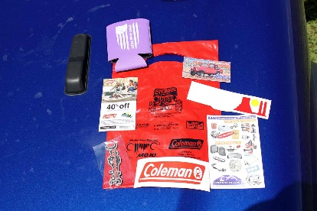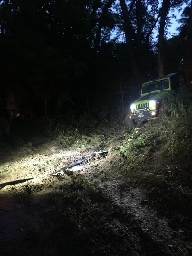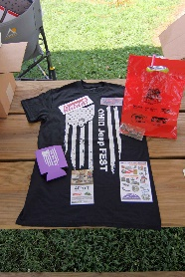
New in 2019 was our on-site trail ride. This trail proved not to disappoint as people would complete the trail and get back in line to run it again. Participants experienced hills, sharp turns, mud, and flexing in order to complete the trail. We had 3 different ways the trail could be completed so participants did not become bored with the same trail over the entire course of the weekend. This year we will look to add another trail and lengthen the original trail. Participants were very excited about this add on in 2019 and will be the perfect opportunity to advertise for your company.
For a donation of $5,000.00
- Exclusive sponsorship of the on-site trail ride.
- Individual company signage at the event.
- Company name on the back of the official Ohio Jeep Fest t-shirts.
- Link to your business website on http://ohiojeepfest.com
- Company logo on the website http://ohiojeepfest.com
- Live announcements by ChillicotheDJ throughout the entire event.
- Company logo on a loop on the electronic sign at the entrance of the Ohio Jeep Fest.
- Vendor Spot.
- All access pass for both obstacle courses and mud pits.
- 20 Weekend passes for the Ohio Jeep Fest.
- 15 official Ohio Jeep Fest t-shirts
- 2 campsites with water and electric for the weekend of the event.

TRAIL LEADER Vendor/Sponsor
For a donation of $1,000.00 sponsors will receive:
1. Individual company signage at the event
2. Link to your business website on http://ohiojeepfest.com/
3. Your company logo on the website http://ohiojeepfest.com/
4. Company name on the back of the Official Ohio Jeep Fest t-shirts (deadline to have name put on back of shirt is May 29th, 2020)
5. Live announcements by ChillicotheDJ throughout the entire event
6. Sponsor logo on a loop on the electric sign at the entrance of the Jeep Fest.
7. Vendor spot
8. All access pass for obstacle courses and mud pits.
9. 5 weekend passes for the Ohio Jeep Fest
10.5 official Ohio Jeep Fest t-shirts

TRAIL LEADER Sponsor
For a donation of $1,000.00 sponsors will receive:
1. Individual company signage at the event
2. Link to your business website on http://ohiojeepfest.com/
3. Your company logo on the website http://ohiojeepfest.com/
4. Company name on the back of the Official Ohio Jeep Fest staff t-shirts (deadline to have name put on back of shirt is May 29th, 2020)
5. Live announcements by ChillicotheDJ throughout the entire event
6. Sponsor logo on a loop on the electric sign at the entrance of the Jeep Fest.
7. All access pass to obstacle courses and mud pits
8. 10 weekend passes for the Ohio Jeep Fest
9. 5 official Ohio Jeep Fest t-shirts
10.1 free campsite rental for the weekend of the event

GUIDE
For a donation of $800.00 sponsors will receive:
1. Group signage with other sponsors at the event
2. Link to your business website on http://ohiojeepfest.com/
3. Your company logo on the website http://ohiojeepfest.com
4. Live announcements by ChillicotheDJ throughout the event
5. 10 weekend passes for the Ohio Jeep Fest
6. 3 official Ohio Jeep Fest t-shirts
7. Sponsor post on the official Ohio Jeep Fest 2020 Facebook page

SPOTTER
For a donation of $600.00 sponsors will receive:
1. Group signage with other sponsors at the event
2. Link to your business website on http://ohiojeepfest.com/
3. Your company name listed on the website http://ohiojeepfest.com/
4. 5 weekend passes for the Ohio Jeep Fest
5. 2 official Ohio Jeep Fest t-shirts
6. Sponsor post on the official Ohio Jeep Fest 2020 Facebook page
7. Prize give away in your company’s name

MUD BOGGER
For a donation of $400.00 sponsors will receive:
1. Group signage with other sponsors at the event
2. Link to your business website on http://ohiojeepfest.com/
3. Your company name listed on the website http://ohiojeepfest.com
4. 5 weekend passes for the Ohio Jeep Fest
5. 2 official Ohio Jeep Fest t-shirts
6. Group sponsor post on the official Ohio Jeep Fest 2020 Facebook page

TAIL GUNNER
For a donation of $200.00 sponsors will receive:
1. Group signage with other sponsors at the event
2. Link to your business website on http://ohiojeepfest.com/
3. Your company name listed on the website http://ohiojeepfest.com/
4. 3 weekend passes to the 2020 Ohio Jeep Fest
5. 1 official Ohio Jeep Fest t-shirt

FRIEND
For a donation of $100.00 sponsors will receive:
1. Group signage with other sponsors at the event
2. Company name listed in a group post with other sponsors on the Ohio Jeep Fest Facebook page
3. 1 weekend pass to the 2020 Ohio Jeep Fest
4. 1 official Ohio Jeep Fest t-shirt
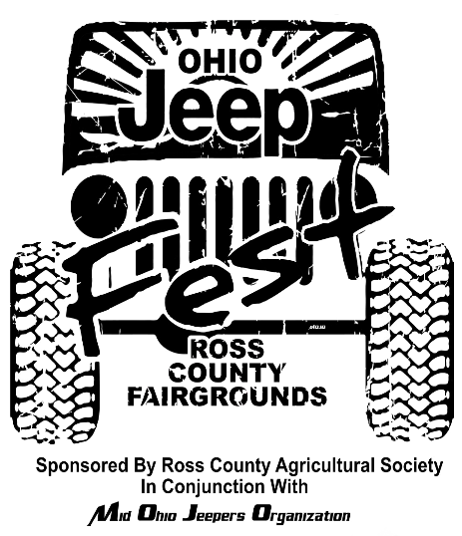
4th Annual Ohio Jeep Fest Sponsorship Form
July 3, 4, & 5, 2019

Company Name:

Address:

Contact Name and Phone number:

Email:

Sponsorship Package: circle option
1. Trail Leader
2. Guide
3. Spotter
4. Mud Bogger
5. Tail Gunner
6. Friend

Shirt Sizes according to sponsor
package.______________________________________________________________
______________________________________________________________________

Payments: Make checks or money orders payable to Ross County Agricultural Society
Mail completed forms to: Ross County Agricultural Society
Attention Barry Haubeil Jr
P.O. Box 614
Chillicothe, OH 45601

